**Name: Amritpal**

**ID: 3157351**

**Title: Inventory System**

# Task 1 - Identify the problem

#### Call Discussion with Client: Harsimran

Client Name : Harsimran

Time : 9:00 am

Date : 28/Oct 2021

After a quick introduction between each other he told me that he has involved in many types of inventory business such as clothes and foot store and he want to store whole record in database and see all of them in one place and he explained me the categories he work in also told that he want one dropdown of categories to store data

He wants to maintain all the parts in his business where he is facing so many problems to maintain the record. He always wastes so much time to find the maintain record on manually. So he has to face so many difficulties to maintain the record for future. So he needs an application for the record maintenance

**Task 2 - Define and document requirements**

Requirement of the Software

Scope of Work

Store all the Products data into database for better record keeping that the client’s deals in.

*Features:*

Harsimran is looking for a website that should be opened on mobile and tablet and big screen properly with any width scrolling means He wants Responsive software compactable to Mobile and Tablet and also it should open quickie means less loading time.

#### Functional Requirements: Demanded requirements by end user:-

1. Easy Navigation
2. Responds to errors(Error handling)
3. Open and work with speed

#### Non-functional requirements:

1. Website should easy to use all members
2. SEO Friendly
3. Performance of system should be good.
4. System should be reliable.

## Time: It will take minimum 19 days to complete.

|  |  |  |  |  |
| --- | --- | --- | --- | --- |
| Name of Tasks | Time | First Day | Last Day | Total |
| Study | 2 Days | 25 Oct | 27 Oct |  |
| Planning | 2 Days | 1 Nov | 3 Nov |  |
| Requirement | 3 Days | 4 Nov | 8 Nov |  |
| Coding (Design) | 5 Days | 9 Nov | 14 Nov |  |
| Coding (Development) | 5 Days | 15 Nov | 21Nov |  |
| Testing | 1 Day | 21 Nov | 22 Nov |  |
|  |  |  |  | 19 Days |

#### Cost

Total Cost $ 2500

Hours Total : 100

Per hour : $ 25

Total : $ 25 *100= $ 2500

## The 4 essential steps of the Risk Management Process are:

#### Identify the risk.

Risk is not certain and can be in any form and so we should be prepared by any kind like as investment from achieving its objective and also it affect identifies objectives of the project

1: project Milestones

2: Scope of the project

3: Financial transition of the project

1. Assess the risk.

While making the project i feel two kind of risk assessments

I.e. qualitative and quantitative

that is used to evaluates the additional cost in the website for example if client says to add some extra feature in the software later on that was not discussed when I was discussing about the requirement and for it he needs to pay extra

1. Treat the risk.

In order to do treatment company must develop a plan and motive of this plan is to decrease the risk occurrence

1. Monitor and Report on the risk.

Risks and opportunities and their treatment plans need to be monitored and reported on.

# Project management:-

When planning for a project evaluation, it’s important to identify the stakeholders and what their short-and-long-term goals are. You must make sure your goals and objectives for the project are clear. It’s critical to have settled on a criteria that will tell you whether these goals and objects are being met.

**Task 3 - Design mockups**

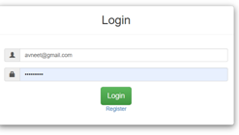

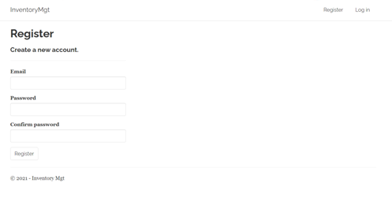

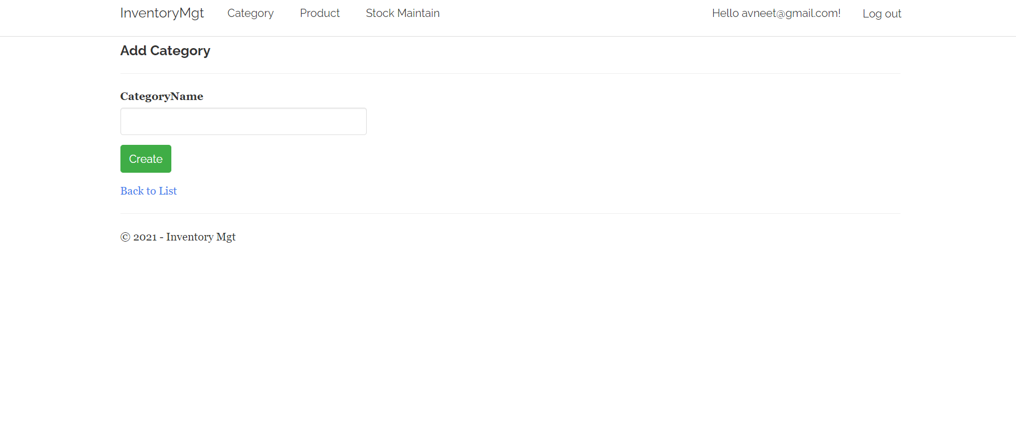

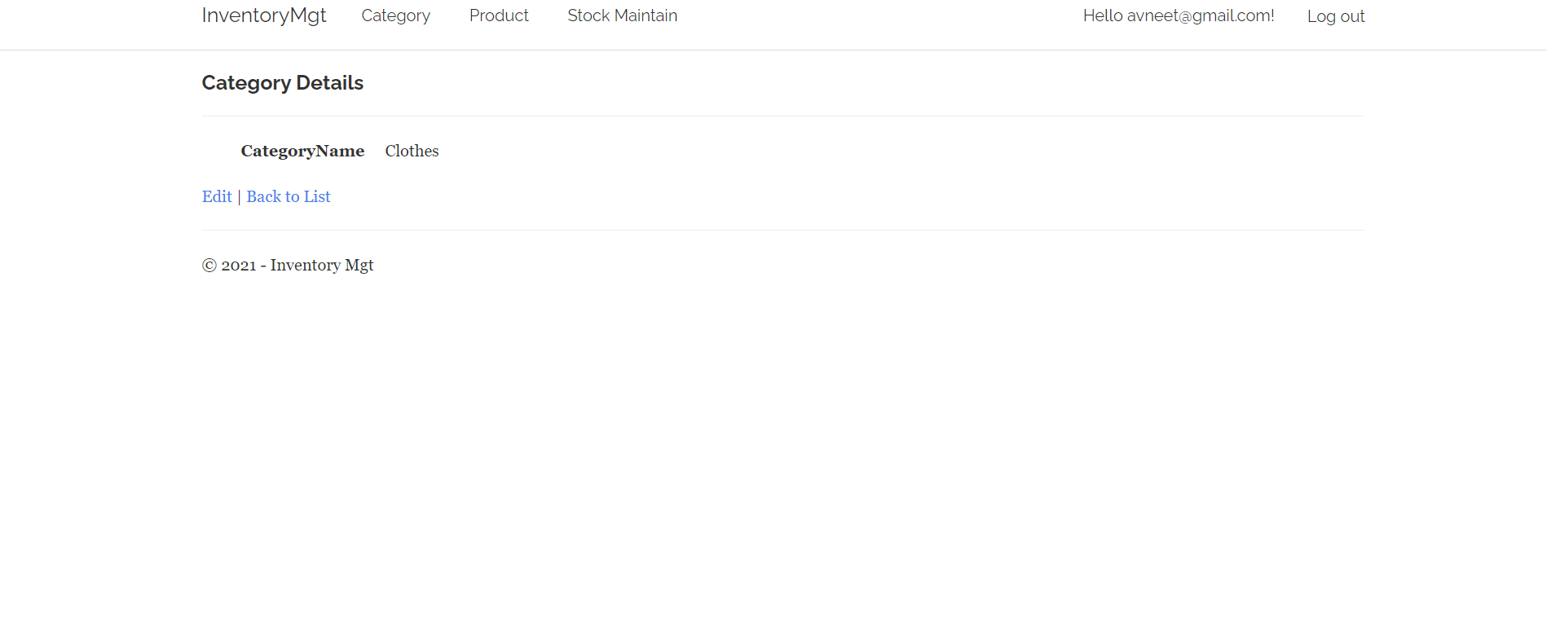

Colour Schema :

Green Button

White Background

Black Text

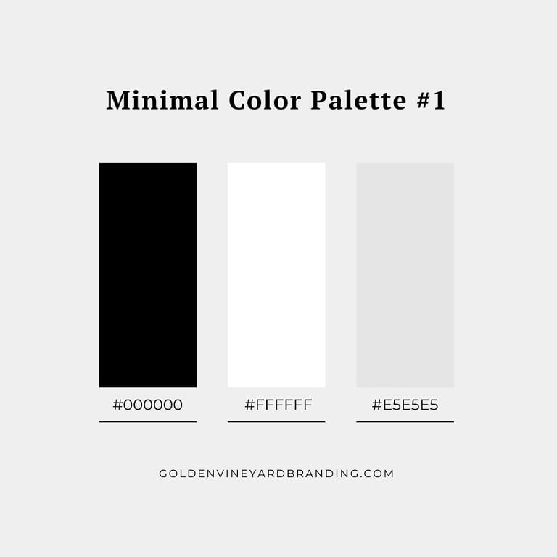

Source: https://www.goldenvineyardbranding.com/

## Task 5- usability testing

1. **Task 1- Food Category form**
2. **Task 2 Food Items Module**
3. **Task 3 Login form**

**User details -**

**User 1 – Male 21yr old , student, good computing skills**

**user 2 - Male 31yr old , worker , Tech Expert**

**user 3 Female 22yr old , Employee, Accountant**

**Result Summary**

|  |  |  |  |  |
| --- | --- | --- | --- | --- |
| **user** | **Task 1 Food Category form** | **Task 2 Food Items Module** | **Login form** | **Reviews** |
| **User 1** | **Completed** | **completed** | **Completed** | **Quick response** |
| **User 2** | **Fast Working** | **Completed** | **Worked next page opened** | **Design Issues** |
| **User 3** | **Worked without problem** | **Worked without error** | **Fast working** | **Very fast working** |

**Task 6 - Meet with your client**

Client Meeting:

|  |
| --- |
| Meeting Details |
| * Date and time: 25-Oct-2021 * Location: Newzealand |
| Attendees: Harsimran and Amrit |
| Agenda: Discussion of Software of Inventory management system |
| Discussion (Important Points): He wants neat and clean software which will work effectively |
| My To Dos (Actions): Firstly I have to make the mockups of the application. Then Starting the application after the next meeting. |
| Questions requiring Follow- Up: Discussion of the mock ups |
| Comments: Harsimran is good person and he described regarding software very wisely. |
| Next meeting  Date and Time: 1- Nov-2021 1:00 Pm  Location: Newzealand  Agenda: Showing the mock ups to the client and discussion about further development. |

**Task 8 - Software development life cycle stages**

**Planning :-**

The planning phase involves aspects of project and product management. This may include:

1. Resource allocation (both human and materials)
2. Capacity planning
3. Project scheduling
4. Cost estimation
5. Provisioning

**Requirement :-** The business must communicate with IT teams to convey their requirements for new development and enhancement. The requirements phase gathers these requirements from business stakeholders and Subject Matter Experts (SMEs.). Architects, Development teams, and Product Managers work with the SMEs to document the business processes that need to be automated through software. The output of this phase in a Waterfall project is usually a document that lists these requirements. Agile methods, by contrast, may produce a backlog of tasks to be performed.

**Software Design and prototyping:-**Once the requirements are understood, software architects and developers can begin to design the software. The design process uses established patterns for application architecture and software development. Architects may use an architecture framework such as TOGAF to compose an application from existing components, promoting reuse and standardization.

Testing : Testing one of the important task in software development as it polishes the software beauties and correct the design issues. Testing starts once the coding is complete and the modules are released for testing. In this phase, the developed software is tested thoroughly and any defects found are assigned to developers to get them fixed.

**Software Development :** This phase produces the software under development. Depending on the methodology, this phase may be conducted in time-boxed “sprints,” (Agile) or may proceed as a single block of effort (Waterfall.) Regardless of methodology, development teams should produce working software as quickly as possible. Business stakeholders should be engaged regularly, to ensure that their expectations are being met. The output of this phase is testable, functional software.

**Testing**

The testing phase of the SDLC is arguably one of the most important. It is impossible to deliver quality software without testing. There is a wide variety of testing necessary to measure quality:

Code quality

Unit testing (functional tests)

Integration testing

Performance testing

Security testing

**Task 9- Project management**

The project evaluation process consists of collecting, recording, and organizing information about project results and lessons learned. It's beneficial for future projects you will be holding. Thanks to tracking project steps on every stage, you are informed about occurring problems, obstacles in the project, and it's much easier to solve issues, adapt changes and finally minimize the risk of project failure. The project process and progress are under control and the decision you make should benefit the organization at all times. Interested in other factors that have an influence on the client & software development team fruitful cooperation process? Check this piece about do's and don'ts of managing an outsourced Ruby on Rails team written from our Project Manager perspective.

### Success

When a task is completed with lot of hard work and skilled work is called success because he require proper guidelines and all other things before completing the task.

### Learning

As I alone was working on this project and this project require lot of online study before completing the project : i learned the following things:

* Time management
* Quality Code writing
* Finalization

### Weakness

Having so big responsibility on hands is a big issue and also has fear pandemic and then collecting data

The definition of success regarding projects is achieving a single project's primary goal. Of course, it's also important to deliver a project within the estimated time and budget. Just remember, your team and project managers should be flexible enough to adapt all changes the project needs so that the quality could be continuously improved. There is no good and bad project quality management methodology - each methodology has its pros and cons.